After watching the first four videos in the Intro to Vue 3 course on Vue Mastery, I've gained a solid grasp of the basics of Vue 3. The first video gives an overview of Vue 3, helping me understand it as a flexible JavaScript framework for building user interfaces, with a strong emphasis on reactivity—meaning the UI automatically updates when data changes. It's an improvement over Vue 2 in terms of performance and simpler syntax, using directives like v-model to handle dynamic data in a declarative way.
Next, the section on creating your first Vue app shows how to set up a simple project using Vue CLI or CDN, and the structure of a .vue file with template, script, and style sections. I clearly saw how basic data binding works through interpolation with {{ }}, which lets you render dynamic content without complicated JavaScript.
The attribute binding video explains v-binssd (or just :) for dynamically attaching HTML attributes like src or href. For example, binding an image URL from a data variable makes the template flexible and reactive, avoiding hardcoded values.
Finally, the conditional rendering part introduces v-if and v-else for showing elements based on conditions, comparing it to v-show, which just hides or shows via CSS. I learned that v-if is better for rarely changing conditions to optimize the DOM, while v-show is ideal for frequent toggling.
Overall, these four videos make me feel like Vue 3 promotes clean, maintainable code that's beginner-friendly. It boosts my confidence in starting to build interactive web apps, as everything revolves around making data "alive" right in the template. (Around 280 words)

Lesson 2:
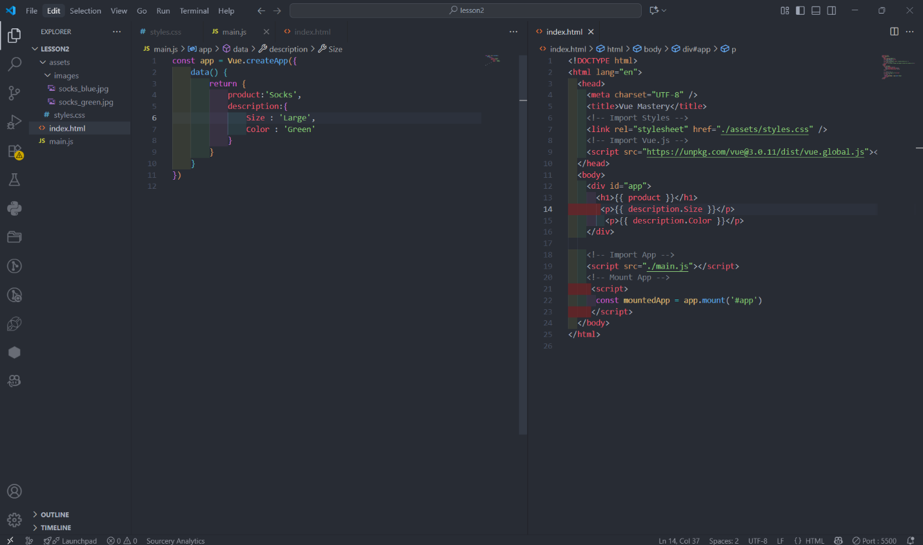

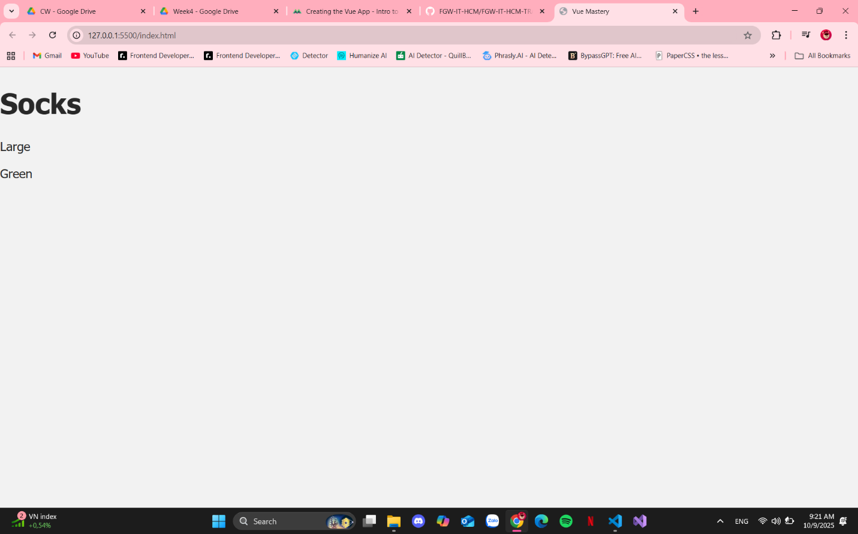

Lesson 3 :
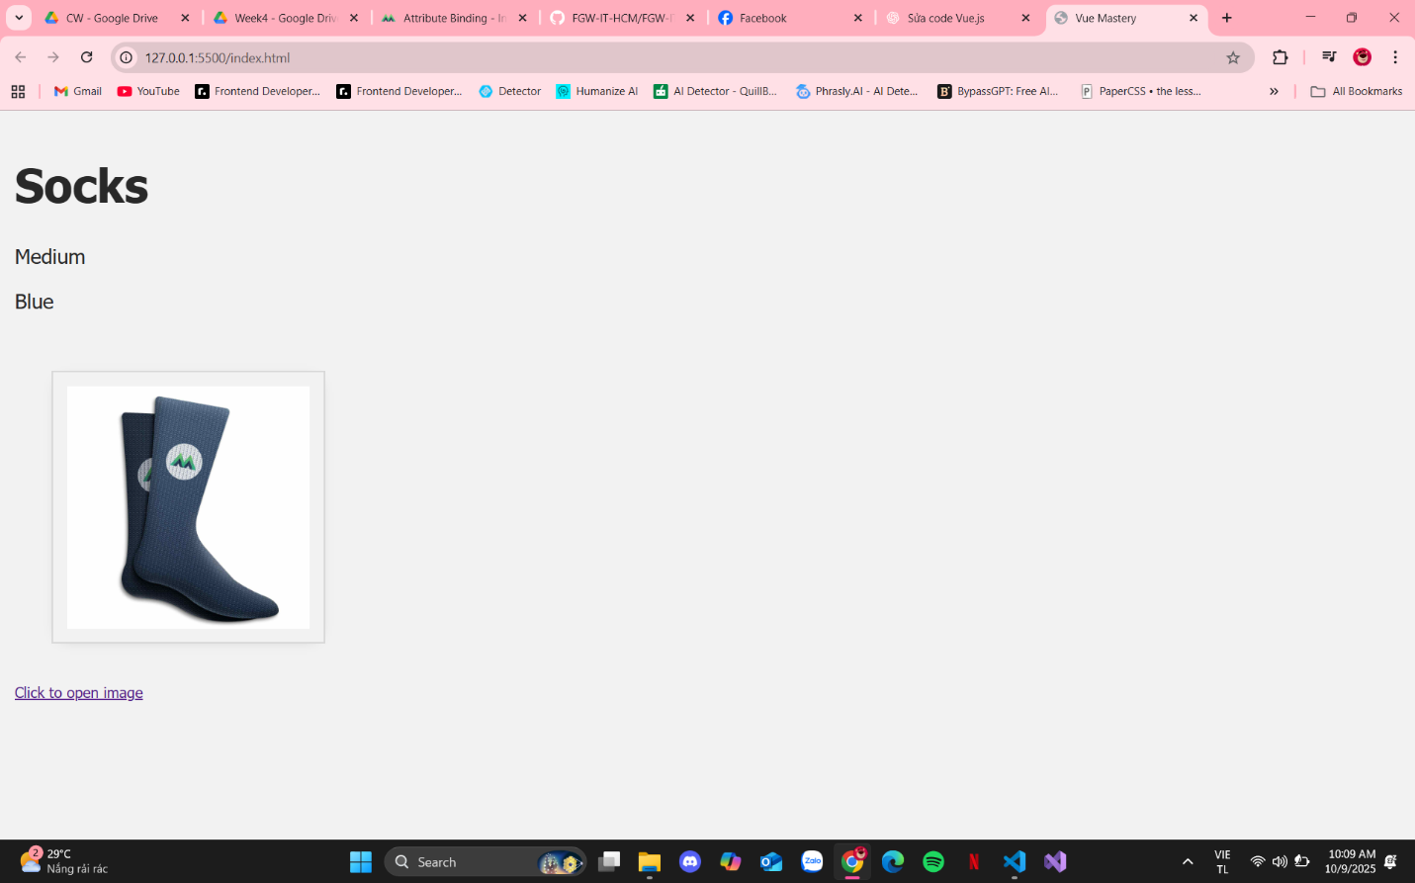

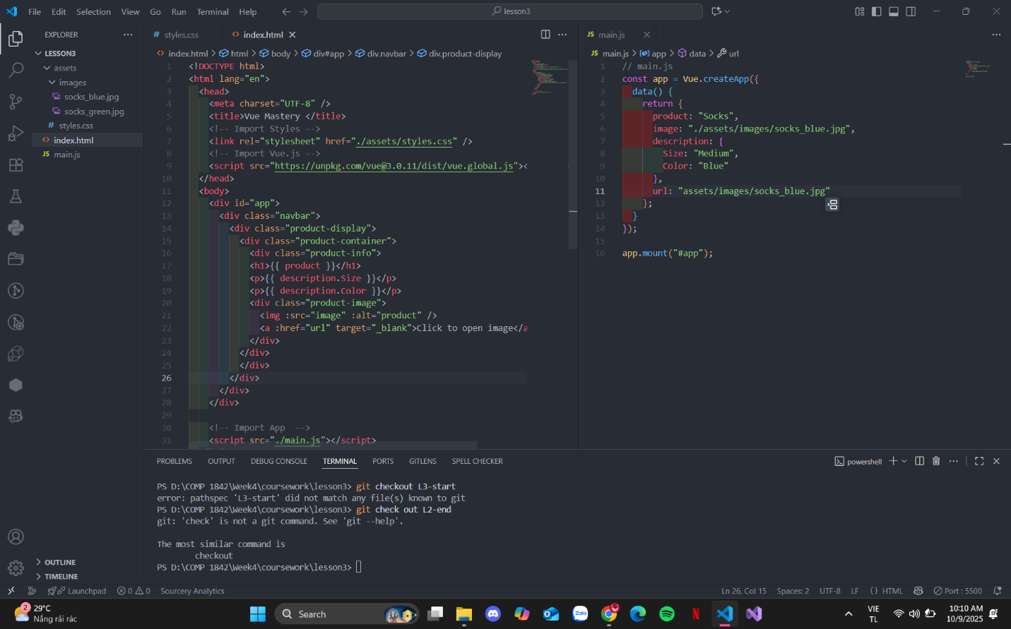

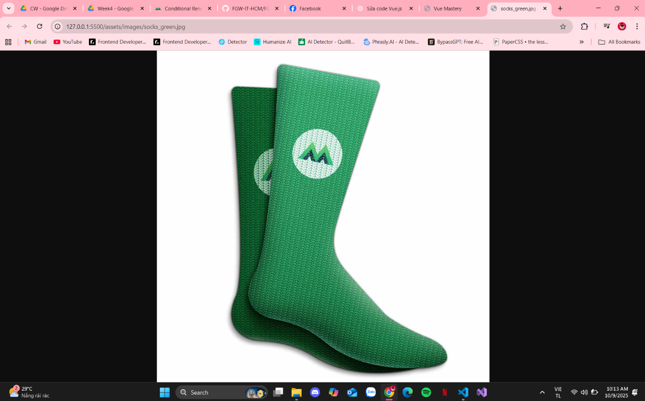

Lesson 4 :
